1. When we install mongoDB, we get some databases and collections out of box but they are not for storing user’s data but system’s data.
2. Let’s examine some commands that are used to display information about databases and collections.
3. **db**: This command is used to show you active database.
   1. Usually if you have just logged into MongoDB shell and it’s a clean MongoDB setup, this database will be **admin database.**
4. **show dbs**: This command lists all databases.
   1. Admin, local and config databases are system databases.
   2. These databases contains system info such as administrative user accounts, MongoDB logs, information related to Replica Set and so on.
5. **Use <database_name>:** To switch to another database.
6. **Show collections**: To list all collections in a database.
7. 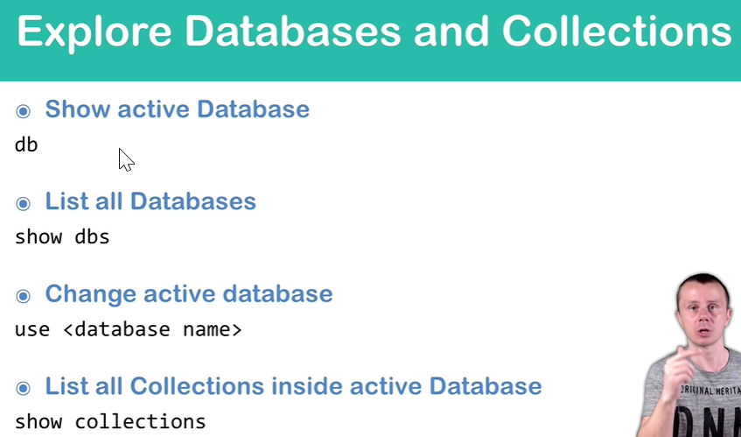
8. 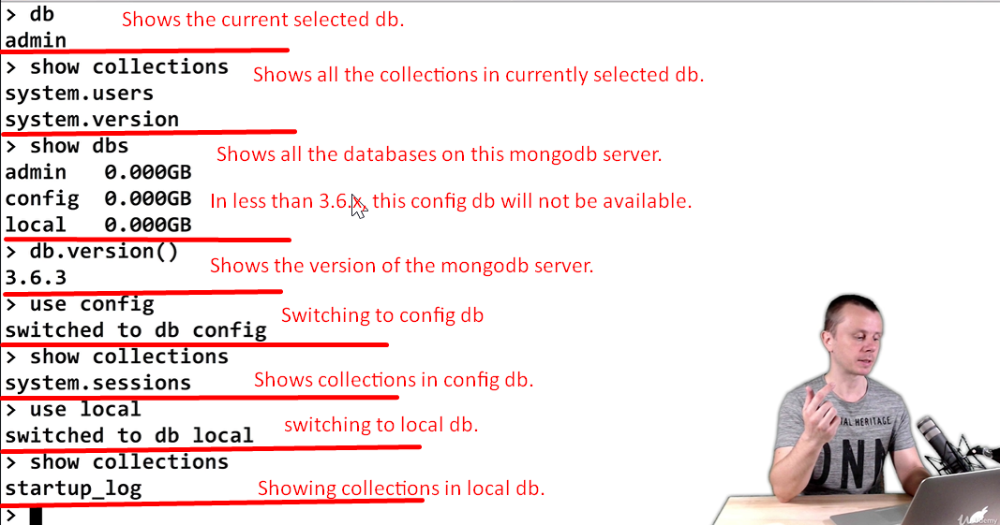
9. 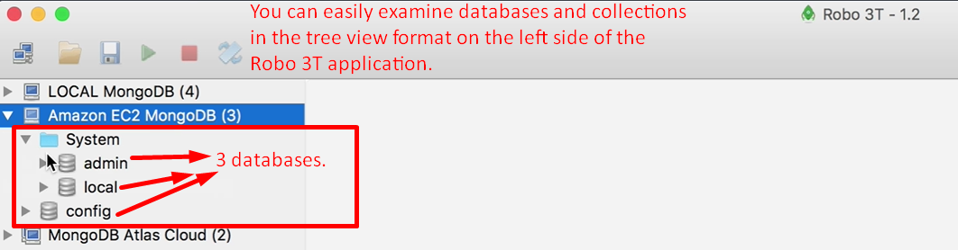
10. 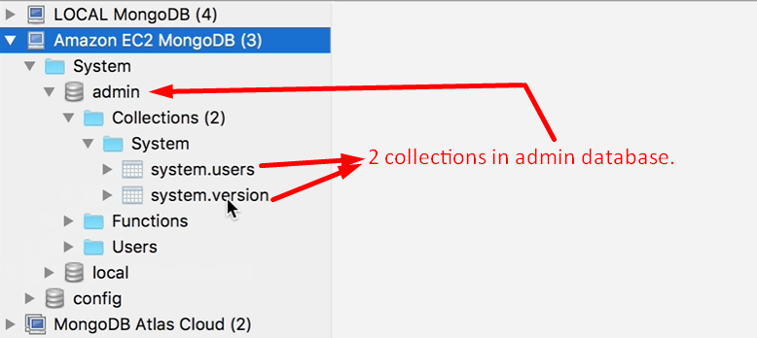
11. 